Customer that is most frequent in travel:

SELECT customer_id, COUNT(*) AS frequency

FROM passengers_on_flights

GROUP BY customer_id

ORDER BY frequency DESC

LIMIT 1;

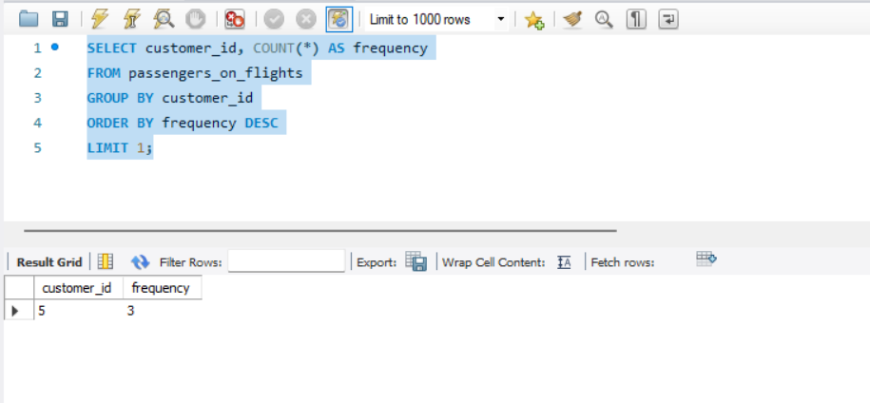

-- 1. Identify Regular Customers: Customers with more than 2 flights

SELECT customer_id, COUNT(*) AS total_flights

FROM passengers_on_flights

GROUP BY customer_id

HAVING total_flights > 2;

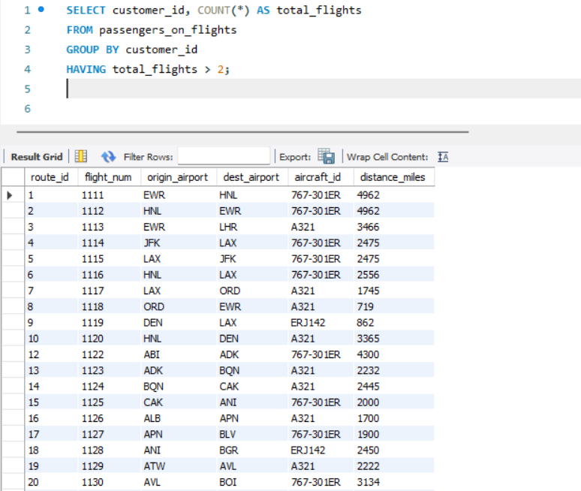

-- 2. Analyze Busiest Route: Route with the highest number of passengers

SELECT route_id, COUNT(*) AS passenger_count

FROM passengers_on_flights

GROUP BY route_id

ORDER BY passenger_count DESC

LIMIT 1;

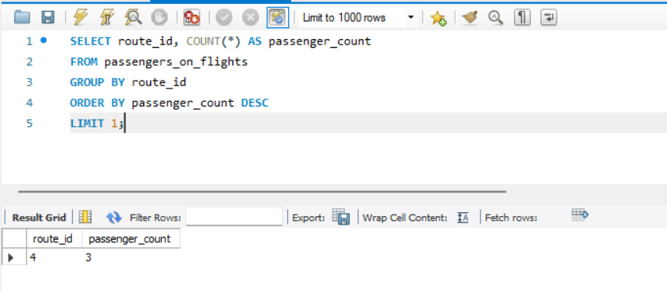

-- 3. Detailed Ticket Sales Analysis: Total revenue and tickets sold per brand

SELECT td.brand,

SUM(td.no_of_tickets) AS total_tickets_sold,

SUM(td.no_of_tickets * td.price_per_ticket) AS total_revenue

FROM ticket_details td

GROUP BY td.brand

ORDER BY total_revenue DESC;

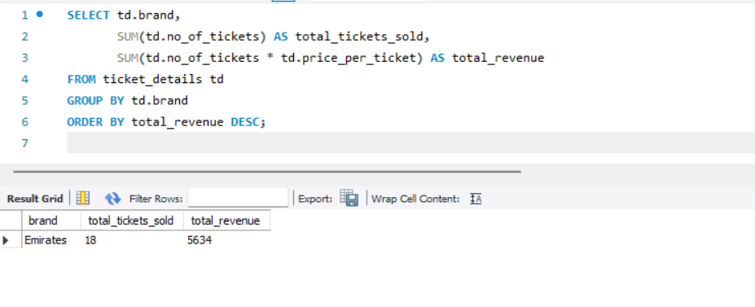

-- 4. Total Revenue per Customer (optional insight for loyalty program)

SELECT td.customer_id,

SUM(td.no_of_tickets * td.price_per_ticket) AS total_spent

FROM ticket_details td

GROUP BY td.customer_id

ORDER BY total_spent DESC;

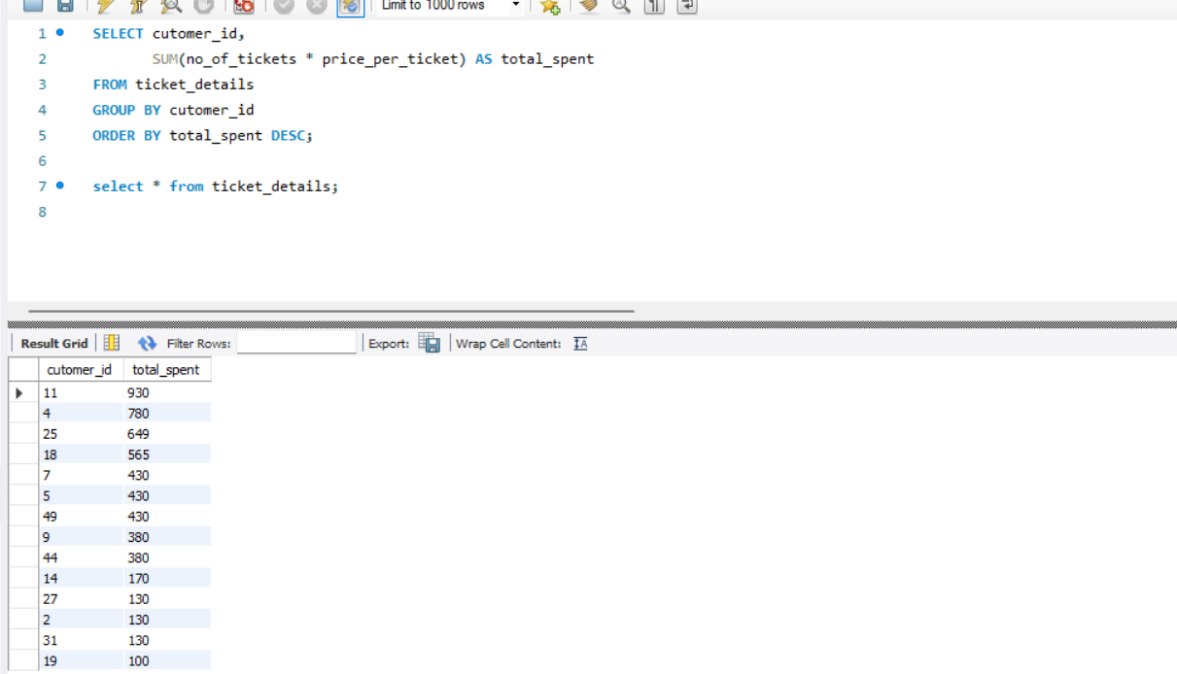

-- 5. Most Frequently Used Aircraft (helps determine fleet demand)

SELECT aircraft_id, COUNT(*) AS total_usages

FROM passengers_on_flights

GROUP BY aircraft_id

ORDER BY total_usages DESC;

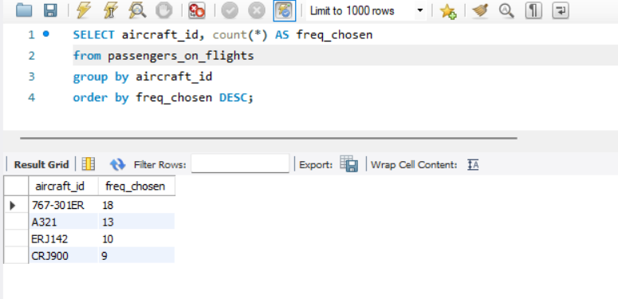

-- 6. Most Popular Class (Economy, Business, etc.)

SELECT class_id, COUNT(*) AS bookings

FROM passengers_on_flights

GROUP BY class_id

ORDER BY bookings DESC;

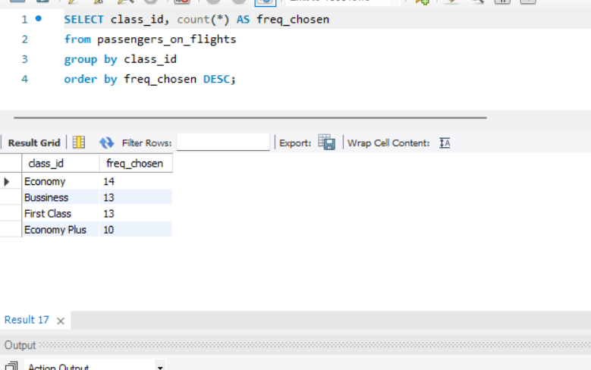

-- 7. Route Details with Distance and Frequency

SELECT r.route_id, r.origin_airport, r.destination_airport, r.distance_miles,

COUNT(pf.route_id) AS flights_count

FROM routes r

JOIN passengers_on_flights pf ON r.route_id = pf.route_id

GROUP BY r.route_id, r.origin_airport, r.destination_airport, r.distance_miles

ORDER BY flights_count DESC;

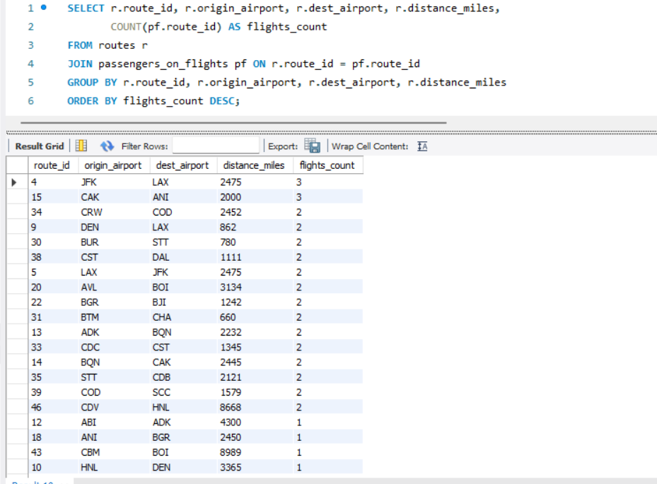

Complete code:

CREATE TABLE customer (

customer_id INT PRIMARY KEY,

first_name VARCHAR(50),

last_name VARCHAR(50),

date_of_birth DATE,

gender VARCHAR(10)

);

CREATE TABLE passengers_on_flights (

customer_id INT,

aircraft_id VARCHAR(10),

route_id INT,

depart VARCHAR(5),

arrival VARCHAR(5),

seat_num VARCHAR(5),

class_id VARCHAR(20),

travel_date DATE,

flight_num INT

);

CREATE TABLE ticket_details (

p_date DATE,

customer_id INT,

aircraft_id VARCHAR(10),

class_id VARCHAR(20),

no_of_tickets INT,

a_code VARCHAR(10),

price_per_ticket DECIMAL(10, 2),

brand VARCHAR(50)

);

CREATE TABLE routes (

route_id INT,

flight_num INT,

origin_airport VARCHAR(50),

destination_airport VARCHAR(50),

aircraft_id VARCHAR(10),

distance_miles INT

);

1. Identify Regular Customers: Customers with more than 2 flights

SELECT customer_id, COUNT(*) AS total_flights

FROM passengers_on_flights

GROUP BY customer_id

HAVING total_flights > 2;

2. Analyze Busiest Route: Route with the highest number of passengers

SELECT route_id, COUNT(*) AS passenger_count

FROM passengers_on_flights

GROUP BY route_id

ORDER BY passenger_count DESC

LIMIT 1;

3. Detailed Ticket Sales Analysis: Total revenue and tickets sold per brand

SELECT td.brand,

SUM(td.no_of_tickets) AS total_tickets_sold,

SUM(td.no_of_tickets * td.price_per_ticket) AS total_revenue

FROM ticket_details td

GROUP BY td.brand

ORDER BY total_revenue DESC;

4. Total Revenue per Customer (optional insight for loyalty program)

SELECT td.customer_id,

SUM(td.no_of_tickets * td.price_per_ticket) AS total_spent

FROM ticket_details td

GROUP BY td.customer_id

ORDER BY total_spent DESC;

5. Most Frequently Used Aircraft (helps determine fleet demand)

SELECT aircraft_id, COUNT(*) AS total_usages

FROM passengers_on_flights

GROUP BY aircraft_id

ORDER BY total_usages DESC;

6. Most Popular Class (Economy, Business, etc.)

SELECT class_id, COUNT(*) AS bookings

FROM passengers_on_flights

GROUP BY class_id

ORDER BY bookings DESC;

7. Route Details with Distance and Frequency

SELECT r.route_id, r.origin_airport, r.destination_airport, r.distance_miles,

COUNT(pf.route_id) AS flights_count

FROM routes r

JOIN passengers_on_flights pf ON r.route_id = pf.route_id

GROUP BY r.route_id, r.origin_airport, r.destination_airport, r.distance_miles

ORDER BY flights_count DESC;